**BENEFITS FOR STUDENTS INVOLVED**

**IN THE IMMERSION PROGRAMME**

### Business Skills

* Meeting targets and deadlines for fundraising
* Accounting & administration skills: making lodgements, paying invoices, keeping records, budgeting
* Text

  Description automatically generatedPresentation skills: on your return from Kolkata your school may ask you to speak about your experience
* Written & verbal communication skills: keeping in touch with HOPE office and your Group Leader
* Research skills
* Team work
* Involvement with local media

### Interpersonal Skills

* Cultural exchange
* Realisation of life in developing countries and how you can help
* Involvement in campaigning and advocacy work
* Building networks of young people to make a difference
* Acting as an Ambassador for your school, family and HOPE
* Building confidence by engaging with the public, schools and business while fundraising,
* Building self-awareness: greater appreciation of the opportunities provided to you by living in a developed society

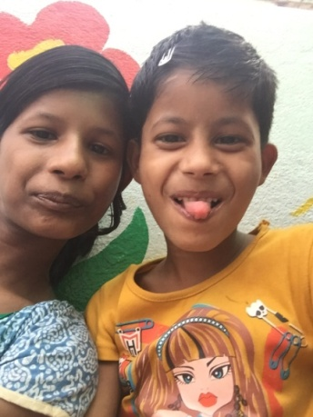

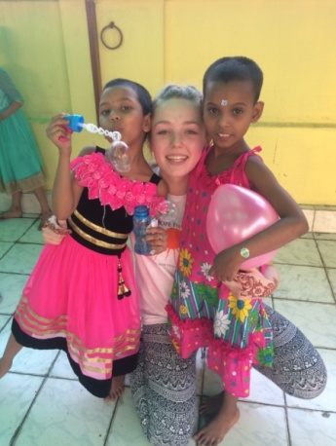

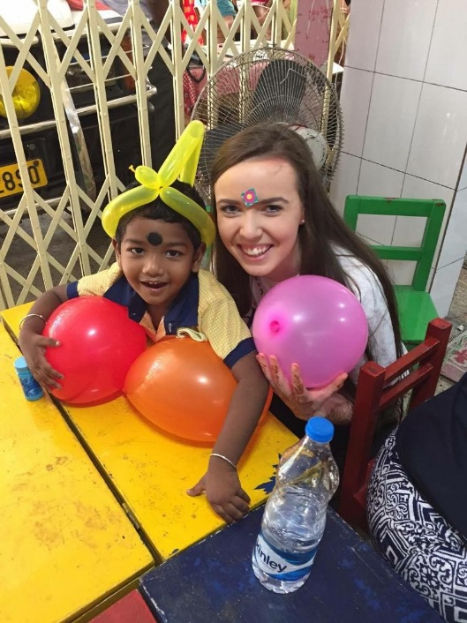

**TESTIMONIALS FROM PREVIOUS STUDENTS AND TEACHERS**

### Students

*I am so honoured to have been part of such an amazing experience. I couldn’t have asked for a better time spent in Kolkata. All the leaders were so kind and helpful and it made the trip so much more enjoyable. I am so thankful that I was given this opportunity and I am so thankful for the outstanding work that HOPE do for the people of Kolkata.* **Laura Walsh, Presentation Secondary, Thurles.**

*If you ever get the opportunity to visit Kolkata with the HOPE Foundation, take it. It was one of the best experiences I have ever done. I would go back in a heartbeat. The happiness and joy you see when you go into a HOPE projects make the fundraising and all the hard work worth it.* **Oisin Mahony, Crosshaven.**

*If anybody ever has the opportunity to do the immersion programme they should absolutely do it. It was easily the best experience of my life and was something I'll never forget.* ***Joe Costigan, Presentation Brothers College, Cork.***

*Not to sound clichéd but it was honestly the most incredible experience of my life. Heading over you just can’t anticipate how the work HOPE does completely changes these children’s lives. Experiencing the abject poverty that many kids came from first hand and seeing that now they have opportunities that they couldn’t have dreamed of before is just totally humbling. You should never underestimate the impact you can have on the lives of others, even just as an individual. I hope to be lucky enough to volunteer for something like this in the future.* ***Aoife O’Driscoll, Mount Mercy College***

### Teacher

*Scoil Ruain have been involved with the Hope Foundation now for 3 successful years ...it has been a brilliant experience ,a journey of great personal and global growth and we will endeavour to remain educators of global citizens within our school through our relationship with the truly brilliant Hope Foundation. I cannot recommend this schools immersion programme highly enough.* **Siobhan Tobin, Scoil Ruain Killenuale.**

### Parent

*I was delighted that my daughter got picked to help out with the Hope Foundation Organisation. From the very beginning, receiving information, help & guidance were in abundance. A lot of effort is required for fundraising but it is truly worth every second. A wonderful, memorable trip, knowing that all the hard work will make a positive difference to many children in Kolkata. A sincere thank you to all involved within the Hope Foundation.* **Rosaleen Fitzgerald***.*

